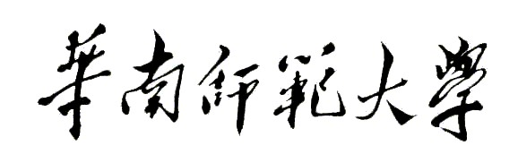
Aberdeen Institute of Data Science and Artificial Intelligence, South China Normal University
Examination of 2021－2022 Academic Year Semester 2
Course Name Paper (A/B)
Programme________________________________Grade______________Class_____________
Name________________________Student ID Number_________________________________
- Title（bold Calibri,font size 14）
1. Questions（Calibri, font size 11, 1.5 Times distance）
2.

