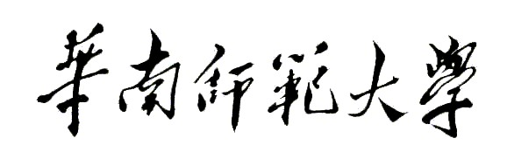
Aberdeen Institute of Data Science and Artificial Intelligence, South China Normal University
Examination of 2021－2022 Academic Year Semester 1
Course Name Paper(A/B)
Answer Booklet and Marking Criteria

- Title（bold Calibri,font size 14）
1. Questions（Calibri, font size 11, 1.5 Times distance）
2.
II.
III.

