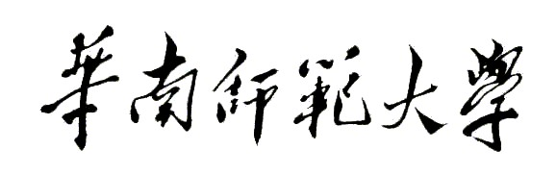
Aberdeen Institute of Data Science and Artificial Intelligence, South China Normal University
Examination of 2022－2023 Academic Year Semester 2
Course Name Paper (A/B)
Answer Booklet
Programme________________________________Grade______________Class_____________
Name________________________Student ID Number_________________________________
Part | I | II | III | IV | V | VI | VII | VIII | IX | X | Total Point
Point

- Title（bold Calibri,font size 14）
1. Questions（Calibri, font size 12, 1.5 Times distance）
2.

