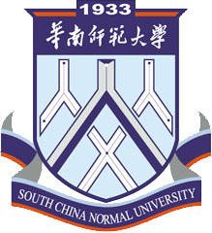
电话：86-20-85211059
传真：86-20-85213352
地址：广东省广州市中山大道西55号
邮编：510631

Certificate
March 22, 2016

To whom it may concern,

This is to certify that Ms. (Passport ID: E ) is a teacher of Economics and Management College, South China Normal University (SCNU) at which she has been working since July 2012. China Scholarship Council will offer her 1,700 US dollars per month，financing her to have a 12 months visit to University of Michigan in United States from July 1, 2016 to June 30, 2017. Total support funding is 1,700*12= 20,400 US dollars. Additionally, during her absence she can still receive her monthly salary about 900 US dollars. Total salary from July 1, 2016 to June 30, 2017 is 900*12=10,800 US dollars. Her employment status will be reserved and she can return to her position as long as she comes back on time.
Hereby certified.

Sincerely,

Personnel Department
South China Normal University

ADD: 55 Zhongshan West Avenue, Guangzhou 510631, P.R. China
TEL: 86-20-85211059 FAX: 86-20-85213352

