陈群教授简介

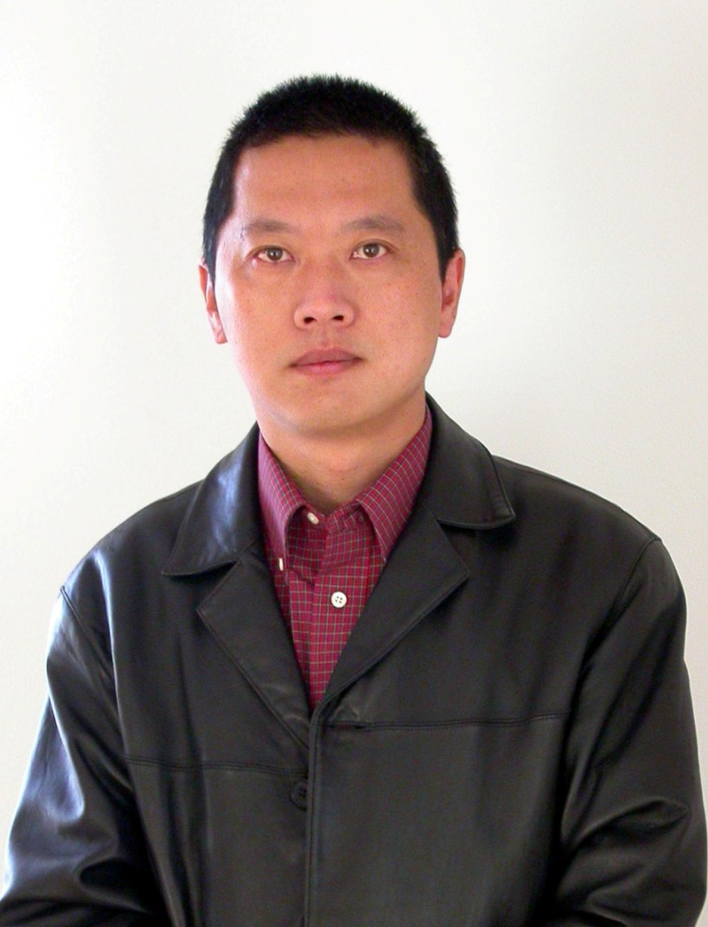
1963年10月生，1984年毕业于复旦大学激光物理专业，1991年在美国密执安州奥克兰大学生物医学专业获博士学位PhD。2002年10月被聘任为广东省激光生命重点实验室光动力学研究中心主任，博士生导师,华南师范大学A岗教授。近年来在Photochem. Photobiol， Radiat. Res.等著名杂志上发表论文几十篇，大部分被SCI系统收录。目前研究方向通过生物组织的正常与异常代谢的光子学直接诊断，进行恶性肿瘤的早期诊断、癌症转移的定量描述；利用高灵敏度的发光探针与单分子标记技术结合，实现高灵敏度的快速早期病变信息诊断；肿瘤光动力治疗中的新型高效光敏剂及其机理研究；光动力学和声动力学肿瘤早期诊断技术及治疗技术研究。为本项目负责人。
所在单位及职称
华南师范大学，生物光子学研究院，教授。
受教育经历（从大学本科开始，按时间倒排序）
1984/09-1988/07，复旦大学，激光物理专业，学士。
1988/09-1991/06， 美国，密执安州，罗切斯特，奥克兰大学，生物医学专业，哲学博士
研究工作经历（按时间倒排序）
1984 - 1986 中国, 上海市。瑞金医院。激光室。助工。
1986 - 1991 美国, 密执安州。奥克兰大学物理系。科研助理
1990– 1993 美国, 密执安州。奥克兰大学物理系。客座讲师
1991 - 1993 美国, 密执安州。底特律市。亨利。福特医院。放射科。光学物理实验室主任。
1993 –2001 美国, 科罗拉多州。丹佛市。HEALTHONE。生物医学物理试验室主任
2001 - 2002 美国，科罗拉多大学康复研究中心。主任
2002– 现在 中国，广东，广州，华南师范大学教育部重点实验室激光生命研究所。教授
主要论著
1. Shengnan Wu, Feifan Zhou,Yanchun Wei, W. R.Chen, Qun Chen,, & Da Xing. Cancer Phototherapy Via Selective Photoinactivation of Respiratory Chain Oxidase to Trigger a Fatal Superoxide Anion Burst. Antioxidants & redox signaling, 2014,20(5), 733-746. (SCI indexed, IF 8.456)
2. Qingzhou Ling, Chengbo Meng, Qun Chen, Da Xing,Activated ERK/FOXM1 Pathway by Low-Power Laser Irradiation Inhibits UVB-Induced Senescence through Down-Regulating p21 Expression, J. Cell. Physiol., (2013), (SCI indexed, IF 7.3)
3．Jiaxing Song, Qun Chen, Da Xing,, Enhanced apoptotic effects by downregulating Mcl-1: Evidence for the improvement of photodynamic therapy with Celecoxib, ,Volume 319, Issue 10, 10 June 2013, Pages 1491–1504
4. Huang Qin, Ting Zhou, Sihua Yang, Qun Chen and Da Xing,GdIII-gold nanorods for MRI-IVPAI dual-modality detection of macrophages in atherosclerotic plaques,Nanomedicine, in press, doi: 10.2217/NNM.12.168 (2013). (SCI indexed, IF 7.3)
5.Xichao Wang, Qun Chen, Da Xing,Focal Adhesion Kinase Activates NF-_B via the ERK1/2 and p38MAPK Pathways in Amyloid-_25-35-Induced Apoptosis in PC12 Cells Journal of Alzheimer’s Disease 32， 2012，77–94.（SCI IF 5.1）
6. Huan Qin, Ting Zhou, Sihua Yang, Qun Chen and Da Xing GdIII-gold nanorods for MRI and PAI dual-modality detection of macrophages in atherosclerotic inflammation Future Nanomedicine，accepted，2012. (SCI indexed, IF 6.0)
7. Cunguang Lou, Sihua Yang, Zhong Ji, Qun Chen, and Da Xing. Ultrashort Microwave-Induced Thermoacoustic Imaging: A Breakthrough in Excitation Efficiency and Spatial Resolution. PHYSICAL REVIEW LETTERS，109, 218101 2012. (SCI indexed, IF 7.3)
8. Aiguo Zhou, Yanchun Wei, Baoyan Wu, Qun Chen, Da Xing Pyropheophorbide a and c(RGDyK) co-modified chitosan-wrapped upconversion nanoparticle for targeted near-infrared photodynamic therapy, Molecular Pharmaceutics, DOI: 10.1021/mp200590y, 2012. (SCI IF 4.5)
9. Yanchun Wei, Qun Chen, Baoyan Wu, Aiguo Zhou and Da Xing.High-sensitivity in vivo imaging for tumor using spectral upconversion nanoparticle NaYF4: Yb+3, Er+3 in cooperation with microtubulin inhibitor. Nanoscale, 4, 3901 2012 .(SCI IF 5.9)
10. Yanchun Wei, Jiaxing Song, Qun Chen,Da Xing, Enhancement of Photodynamic Antitumor Effect With Pro-Oxidant Ascorbate. Lasers Surg Med, 44期, pp 69-75, 2012.(SCI收录)
11. Hongyou Zhao, Da Xing, Qun Chen, New insights of mitochondria reactive oxygen species generation and cell apoptosis induced by low dose photodynamic therapy European JournaL of Cancer, 47卷, pp 2750-2761,(2011).(SCI收录)
12. Yanchun Wei, Jiaxing Song, Qun Chen， 'In vivo Detection of Chemiluminescence to Monitor Photodynamic Threshold Dose for Tumor Treatment' has been passed to our Editorial Production department. Photochem. Photobiol. Sci., Photochemical & Photobiological Sciences, 10(6), pp 1066-1071, 2011.(SCI).(SCI收录)
13 Li, Yunlong, Xing, Da, Chen, Qun, Chen, Wei R Enhancement of chemotherapeutic agent-induced apoptosis by inhibition of NF-kappa B using ursolic acid International Journal of Cancer, 127(2), pp 462-473, 2010.(SCI收录)
14. Ying Yang, Da Xing, Feifan Zhou, Qun Chen,Mitochondrial autophagy protects against heat shock-induced apoptosis through reducing cytosolic cytochrome c release and downstream caspase-3 activation, Biochem. Biophys. Res. Commun., 395, 190-195, 2010. (SCI收录)
15. Liyong Yang, Yanchun Wei, Da Xing, and Qun Chen, “Increasing the Efficiency of Photodynamic Therapy by Improved Light Delivery and Oxygen Supply Using an Anticoagulant in a Solid Tumor Model Lasers in Surgery and Medicine 42:671–679， 2010. (SCI收录)
16. Shiming Luo, Da Xing, Yanchun Wei, Qun Chen，“Effect of Mitochondrial Photosensitizer Photofrin on Cellular Autophagy” Journal of Cellular Physiology, Volume 224, Issue 2 (p 414-422), 2010. (SCI收录)
17. Shiming Luo, Qun Chen, Eduardo Cebollero, Da Xing“Mitochondria: One of the origins for autophagosomal membranes?” Mitochondrion 9（4），227-231， 2009. (SCI收录)
18. Y. C. Wei,, D Xing, S.m. Luo (1), W. Xu , Q. Chen “Monitoring singlet oxygen in situ with delayed chemiluminescence to deduce the effect of photodynamic therapy,” J. Biomed. Opt. 09493, 2010. (SCI收录)

