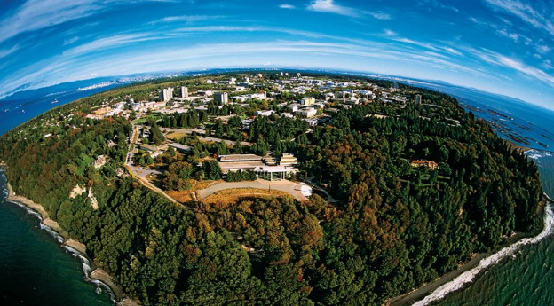

University of British Columbia
2023 International Teacher Education Program
Proposal

Feb 2023
(3-week program)

Faculty of Education
The University of British Columbia
Vancouver, Canada

UBC International Teacher Education Program Schedule 2023

Week 1 Theme: Introduction to Canadian Education

Monday | Program Schedule
10:00-12:00 | Welcome to UBC and Program Overview  Participants will receive an overview of the course structure and requirements, learning goals, readings, formative, and summative course assessments. We will also focus on building a classroom community and getting to know each other as learners.
12:00-1:00 | Lunch
1:00-3:00 | Library Orientation and Campus Tour

Tuesday | Program Schedule
10:00-12:00 | Introduction to British Columbia’s Curriculum I  Participants will examine the foundations of British Columbia’s educational context and explore the curriculum both in a general sense as well as through their disciplinary lens.
12:00-1:00 | Lunch
1:00-3:00 | Introduction to British Columbia’s Curriculum II  Participants will explore the Core and Curricular Competencies and examine their roles as the foundation of teaching and learning.

Wednesday | Program Schedule
10:00-12:00 | Curriculum/ Unit Development I  Participants will explore the fundamentals of a well-designed  unit/lesson in the context of the British Columbia Curriculum. Participants will explore unit/ lesson planning tools that support the incorporation of big ideas, concepts and essential questions.
12:00-1:00 | Lunch
1:00-3:00 | Canadian Society, Culture and Heritage  Participants will be provided with an introduction to Canadian history, traditions, and culture that impact contemporary Canadian education.

Thursday | Program Schedule
10:00-12:00 | Curriculum/ Unit Development II  Participants will continue to explore the fundamentals of a well- designed unit/lesson in the context of the British Columbia Curriculum. Participants will work on their summative unit using the planning tools that support the incorporation of big ideas, concepts, essential questions and inquiry.
12:00-1:00 | Lunch
1:00-3:00 | Curriculum/ Unit Development III  Participants will continue to explore the fundamentals of a well- designed unit/lesson in the context of the British Columbia Curriculum. Participants will work on their summative unit using the planning tools that support the incorporation of big ideas, concepts, essential questions, and inquiry.

Friday | Program Schedule
Full Day | School visit

Week 2 Theme: Creating Thinking Classrooms: Moving from Theory to Practice

Monday | Program Schedule
10:00-12:00 | Debrief school visits  Examples of Best Practice in BC Education – Inquiry-based Learning I  Participants will examine the processes of creating and implementing inquiry teaching and learning in their classroom
12:00-1:00 | Lunch
1:00-3:00 | Examples of Best Practice in BC Education – Inquiry-based Learning II  Participants will examine the processes of creating and implementing inquiry teaching and learning in their classroom

Tuesday | Program Schedule
10:00-12:00 | Reimagining Student Assessment I- Summative Assessment  Participants will examine the key principles of quality assessment, and different types of summative assessment frameworks, and explore classroom assessments used in British Columbia’s classrooms.
12:00-1:00 | Lunch
1:00-3:00 | Reimagining Student Assessment II- Formative Assessment  Participants will examine the key principles of quality assessment, and different types of formative assessment frameworks, and explore classroom assessments used in British Columbia’s classrooms.

Wednesday | Program Schedule
10:00-12:00 | Innovative Teaching Strategies I  Participants will examine various innovative teaching strategies and their impact on student learning.
12:00-1:00 | Lunch
1:00-3:00 | Innovative Teaching Strategies II  Participants will examine various innovative teaching strategies and their impact on student learning.

Thursday | Program Schedule
Full day | Victoria Day Trip

Friday | Program Schedule
Full Day | School visit

Week 3 Theme: Theory to Practice: Deepening and Sharing Our Learning

Monday | Program Schedule
10:00-12:00 | Debrief school visits  Reimagining Student Assessment III  Participants will explore the shifting practices in classroom assessments.
12:00-1:00 | Lunch
1:00-3:00 | Reimagining Student Assessment IV Project work/ tuning  Participants will explore the shifting practices in classroom assessments.

Tuesday | Program Schedule
10:00-12:00 | Examples of Best Practice in BC Education  – Social Emotional Learning I  Participants will examine the research and requirements on teaching Social and Emotional Learning. Participants will review school and classroom-based strategies to further students’ growth in these areas.
12:00-1:00 | Lunch
1:00-3:00 | Examples of Best Practice in BC Education  – Social Emotional Learning II  Participants will examine the research and requirements on teaching Social and Emotional Learning. Participants will review school and classroom-based strategies to further students’ growth in these areas.

Wednesday | Program Schedule
10:00-12:00 | Examples of Best Practice in BC Education – STEM Education  Participants will learn about research and practice of 21st century STEM education. Participants will consider innovative STEM curricula and how they can be implemented in both formal and informal contexts.
12:00-1:00 | Lunch
1:00-3:00 | Project work

Thursday | Program Schedule
10:00-12:00 | Group Summative Unit Presentations
12:00-1:00 | Lunch
1:00-3:00 | Group Summative Unit Presentations

Friday | Program Schedule
10:00-12:00 | Reflecting on our learning  Participants will explore ways to establish a sense of belonging for their students and explore strategies to engage students in their learning.
12:00-1:00 | Lunch
1:00-3:00 | Graduation Ceremony
** Independent learning activities include open lectures, seminars, and library search, etc. Participants will be provided with a schedule of activities available on campus to choose from.
*Details of the program are subject to change.

