

华南师范大学South China Normal University
2026年秋季学期来华留学生新生报到指南
Registration Instruction for International Students, Fall 2026
各位同学：
Dear International Students,
你们好！欢迎来到美丽的华南师范大学！为做好2026年秋季学期报到工作，请您仔细阅读以下指南。
Welcome to South China Normal University! To help you prepare for the Fall 2026 registration, please read the following instruction carefully.
- 报到时间、地点及流程 Registration Date, Place and Procedure

（一）报到时间和地点 Registration Date & Place
报到时间  Registration Date | 2026年9月4–5日09:00–12:00，14:30–17:30, Sep 4th -5th
报到地点  Registration Place | 华南师范大学（石牌校园）国际文化学院一楼大厅（田家炳教育书院）  Lobby, 1st Floor, School of International Culture (SIC) –  Tian Jiabing Education Building, Shipai Campus, SCNU

(二）报到流程 Registration Procedure
已获录取资格并办理好学生签证（X1或X2）的同学，请持以下材料前来报到注册：
Students who have been admitted and have obtained a student visa (X1 or X2) should bring the following documents to register.
- 录取通知书/ Admission Notice
- 外国留学人员来华签证申请表（JW202或DQ表）/ Visa Application Form for Study in China (JW202 or DQ)
- 有效护照（原件）/ Valid passport (original)
- 最终学历证明原件及HSK成绩报告（原件），本科生还需提供CSCA成绩单原件/Final education diploma and HSK score report（original）。Undergraduate students provide CSCA test report as a plus.
- 来华留学生综合医疗保险证明/ Comprehensive medical insurance certificate for international students in China
- 境外人员体格检查记录验证证明（X1签证请在入境后完成体检）/ Verification Certificate of Physical Examination Records for Overseas Personnel (required for X1 visa holders)
★ 重要提示 Important Notes:
- 所有学生须按时报到。请严格按照报到时间入境中国，早于或晚于报到时间5天以上者，学校将无法受理签证。
All students must register on time. Please enter China strictly according to the registration dates. If you arrive more than 5 days earlier or later, the university will not be able to process your visa procedures.
- 如有特殊情况，须提前发邮件联系学校并征得同意。
If you have special circumstances, you must send an email to the university for approval in advance.
- X1签证入境后有效期为30天，须在入境后15天内提交全部签证材料至签证办公室（A101），逾期责任自负。
X1 visa holders have a 30-day validity upon entry. All visa documents must be submitted to the Visa Office (Room A101) within 15 days of entry. Any delay will be your own responsibility.
联系方式 Contact:
电话 Tel: 0086-20-85215350 / 85210012
邮箱 Email: hscic7@scnu.edu.cn

二、学费标准、缴费方式及账户

Tuition Fees, Payment Methods and Bank Account

（一）学费标准 Tuition Fee Standards
语言进修生（普通班）  Chinese Language Program  Non-degree (Regular Class) | 8,900元/学期; 17,000元/年  RMB 8,900/ semester; RMB 17,000/year
语言进修生（强化班）  Chinese Language Program  Non-degree (Intensive Class) | 16,500元/学期 RMB 16,500/semester
本科生 Undergraduate | 21,000元/年 RMB 21,000/year
硕士生 Master | 29,000元/年 RMB 29,000/year
博士生 Doctoral | 34,000元/年 RMB 34,000/year
备注 Notes:
- 在华留学生须缴纳人民币；海外留学生可缴纳美元。
Students in China must pay in RMB; overseas students may pay in USD.
- 持X1签证入学者，须交纳一年学费方可申请居留许可签证。
X1 visa holders must pay one full year's tuition before applying for a residence permit.
- 语言进修生如学习期限为一学期，可按学期缴纳；一学年及以上建议按年缴纳。
Chinese Language Program (Non-degree) students with one-semester duration may pay by semester; those with one year or more are advised to pay annually.

（二）缴费方式 Payment Methods
- 现金支付（报到时现场缴纳）/ Cash (on-site at registration)
- 微信、支付宝或银联支付 / WeChat, AliPay, UnionPay
- 银行转账（账户信息如下）/ Bank Transfer (account details as below)
转账至以下账户 Transfer to the Following Account:
开户银行账号 Account Number | 3602008109000386071
纳税人名称 Account Name | 华南师范大学 South China Normal University
开户行名称 Bank Name | 工行广州高新技术开发区支行  ICBC Gaoxin Branch, Guangzhou City
SWIFT CODE | ICBKCNBJGDG
转账须知 Important Reminders for Transfers:
- 转账单上须注明付款人、收款人信息及时间，务必备注本人护照号码或申请编号。/ The transfer slip must show payer/payee info and time. You MUST indicate your passport number or application ID in the remarks.
- 请勿分批转账 / Do NOT transfer in installments.
- 转账金额请确认已包含手续费（到账须为足额学费）/ Ensure the transfer amount includes all bank charges.
- 转账后请扫描/拍照转账单据发送至 hscic7@scnu.edu.cn / Scan or photograph the slip and send to hscic7@scnu.edu.cn.
- 本账户仅接受学费转账，不接受住宿费转账，操作错误者责任自负。 / This account is for tuition ONLY. Do NOT transfer accommodation fees here. You shall bear full responsibility for any errors.
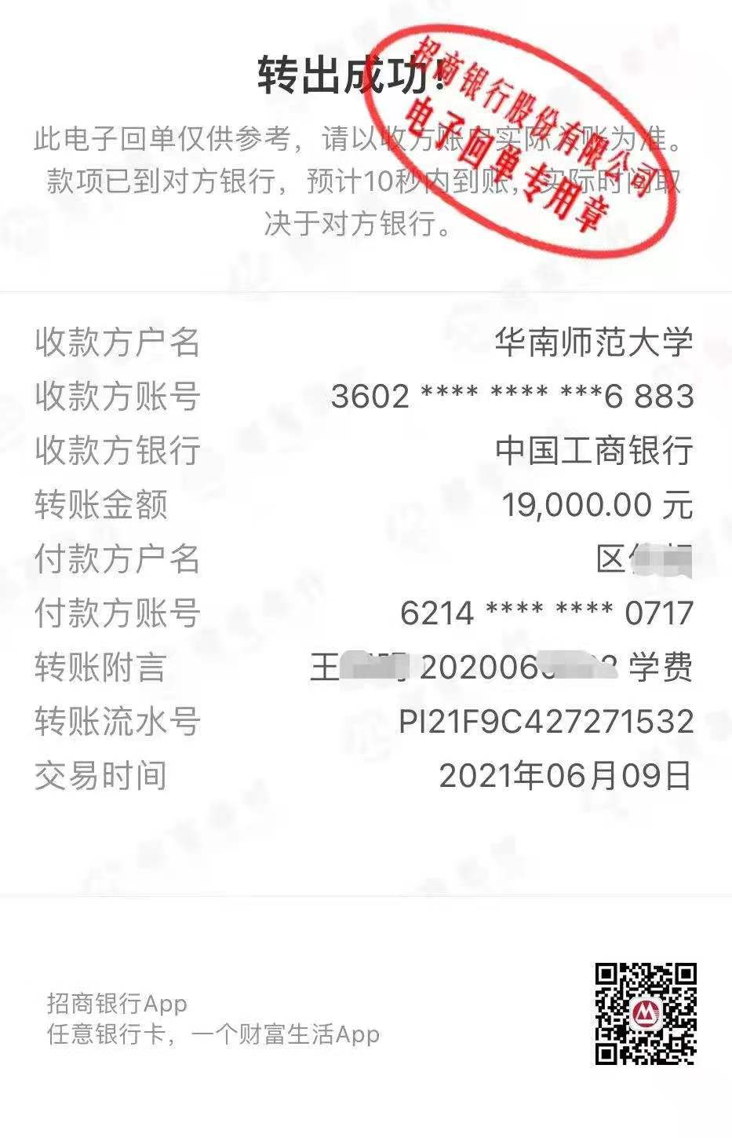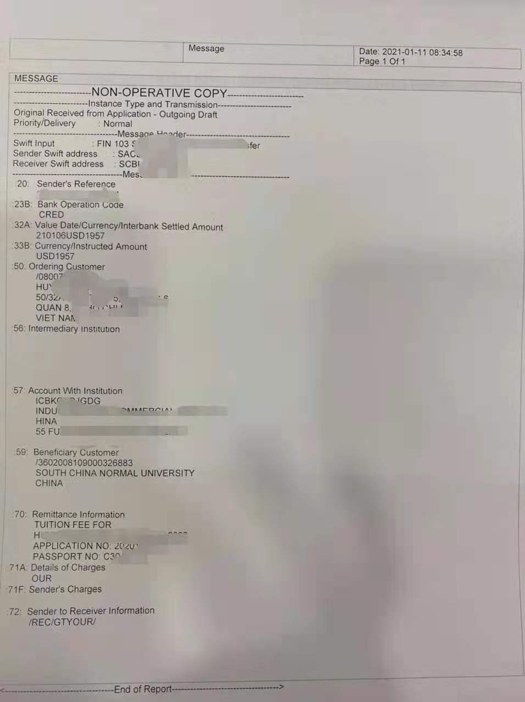

三、签证与居留许可 Visa and Residence Permit
- 学校仅接受持X1（长期学习）和X2（短期学习）签证的同学报到学习。
The university only accepts students holding X1 (long-term) or X2 (short-term) visas.
- X1签证入境后有效期为30天，须在入境后15天内提交签证材料至A101。
X1 holders have 30-day validity upon entry. Submit all materials to Room A101 within 15 days.
- X2签证只有一次出入境机会，持有者须在签证有效期内完成学习并按时离境。
X2 holders only has one entry, must complete studies and leave within visa validity.
- 签证办理所需材料请以签证办公室通知为准。附件1是签证办理所需材料及流程。Required documents are subject to Visa Office notice. Attachment 1 contains the required documents and application procedures for visa processing.
- 签证咨询：hscic7@scnu.edu.cn / 0086-20-85215350 / 85210012。
Visa inquiries: hscic7@scnu.edu.cn / 0086-20-85215350 / 85210012.
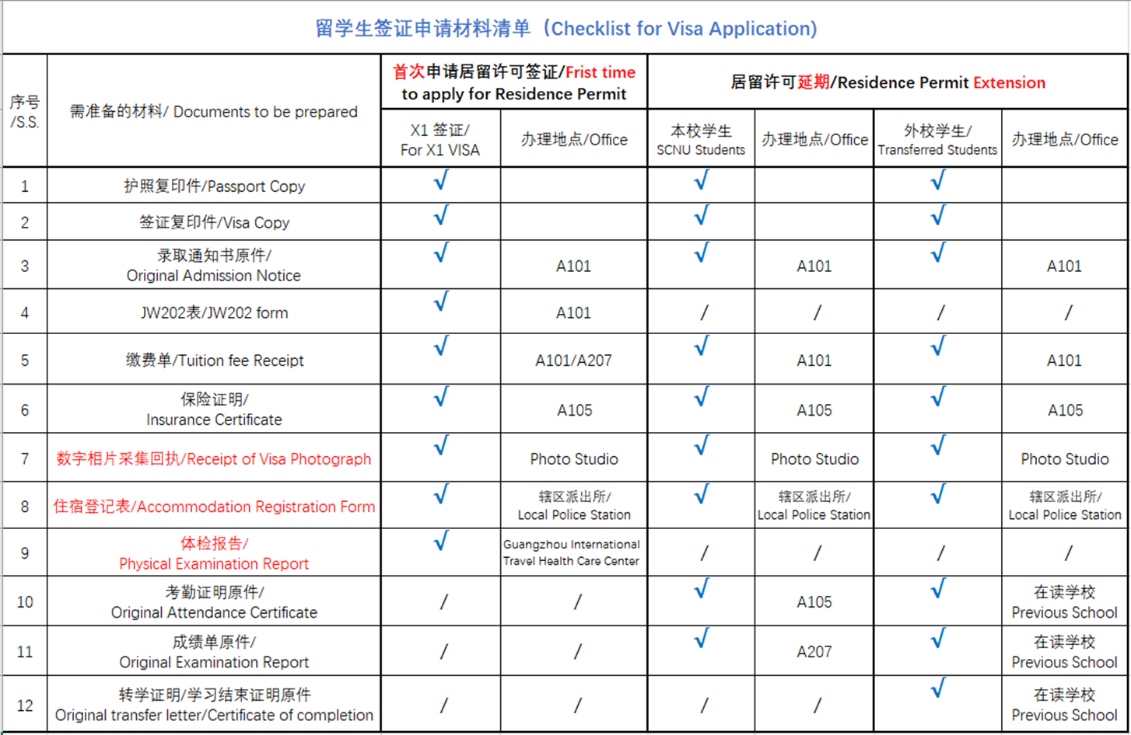

四、宿舍安排 Accommodation Arrangements
- 2026年秋季学期校内留学生公寓房间有限，仅双人间可供学历生预定（先定先得）。语言生（非学历生）一律不安排校内住宿。
On-campus dormitories are limited. Only double rooms are available for degree-program students on a first-come, first-served basis. On-campus housing is not provided for language students (non-degree program).
- 住宿费：12,000元/年，可按学期分2次缴纳（6,000元/学期）。
Dorm Fee: RMB 12,000/year, payable in 2 installments (RMB 6,000/semester).
- 预定方式：请在7月15日前发送邮件至 20161043@m.scnu.edu.cn，注明护照号码、中文姓名及学习期限。
Reservation: Email 20161043@m.scnu.edu.cn before July 15 with your passport number, Chinese name, and study duration.
- 校外住宿：学校周边单间月租金约2,000–3,000元。校外住宿学生须在入住后24小时内办理临时住宿登记并提交签证办公室备案。附件2是学校周边的公寓情况，学生可自行咨询并预定。
Off-campus housing: Monthly rent approx. RMB 2,000–3,000. Off-campus students must register temporary residence at local police station within 24 hours and submit to Visa Office. Please refer to Attachment 2 for information on apartment options near the campus. Students may contact the properties directly for inquiries and reservations.

五、保险要求 Insurance Requirements
根据中国教育部规定，所有来华留学生须在中国大陆购买来华留学生综合医疗保险（含意外伤害和住院医疗），费用约800-1200元/年。未购买保险者不予办理报到注册手续。可在报到现场购买或自行购买符合要求的产品（须覆盖全部学习期间）。保险购买请参考附件3.
According to Ministry of Education regulations, all international students must purchase comprehensive medical insurance (covering accident and hospitalization) in mainland China, approx. RMB 800~1200/year. Students without insurance will NOT be permitted to register. Insurance can be purchased on-site or elsewhere, provided it covers your entire study period. Please refer to Attachment 3 for insurance purchase.

六、体检要求 Medical Examination Requirements
持X1签证入境的学生，须在入境后尽快前往广东国际旅行卫生保健中心或其他指定机构完成体格检查，体检合格后方可办理居留许可。详情详见附件1。X1 visa holders must undergo a physical exam at the Guangdong International Travel Health Care Center or other designated institution as soon as possible after entry. For more details, please check Attachment 1.

七、报到交通指引 Transportation Guide
1. 从广州白云机场出发 From Guangzhou Baiyun Airport:
乘地铁3号线北延段至体育西路站，换3号线（天河客运站方向）至华师站，E出口，至西门，直行至田家炳教育书院。
Take Metro Line 3 North Ext. to Tiyu Xilu, transfer to Line 3 (to Tianhe Coach Terminal) to SCNU Station, Exit E, arrive at West Gate, walk straight to Tian Jiabing Building.
2. 从广州南站出发 From Guangzhou South Railway Station:
乘7号线至汉溪长隆，换3号线（天河客运站方向）至华师站，E出口，至西门，直行至田家炳教育书院。
Take Line 7 to Hanxi Changlong, transfer to Line 3 (to Tianhe Coach Terminal) to SCNU Station, Exit E, West Gate, straight to Tian Jiabing Building.
3. 从广州火车站/广州东站出发 From Guangzhou Railway Station / East Railway Station:
- 广州火车站：5号线至珠江新城，换3号线（天河客运站方向）至华师站，E出口。
Guangzhou Railway Stn: Line 5 to Zhujiang New Town, transfer to Line 3 to SCNU Station, Exit E.
- 广州东站：3号线北延段至体育西路，换3号线（天河客运站方向）至华师站，E出口。
Guangzhou East Stn: Line 3 North Ext. to Tiyu Xilu, transfer to Line 3 to SCNU Station, Exit E.
4. 打车/网约车 By Taxi/Ride-hailing:
导航至“华南师范大学石牌校园西门”或“田家炳教育书院”，报到日可能交通管制，请预留时间。
Navigate to "SCNU Shipai Campus West Gate" or "Tian Jiabing Education Building." Allow extra time for possible traffic control.

八、2026年秋季学期时间表 Fall 2026 Semester Schedule
学期 Semester | 学期时间 Duration | 注册时间 Registration | 上课时间 Class Start | 寒假 Winter Break
2026年秋季 Fall 2026 | 2026.9.7 – 2027.1.25 | 2026.9.4–5 | 2026.9.7 | 2027.1.25 – 2.21

九、报到期间现场服务 On-site Services During Registration
- 照相服务 Photo Services: X1签证同学可现场拍摄签证/居留许可照片。 / X1 holders can take visa/residence permit photos on-site.
- 手机卡办理 SIM Card: 现场设中国移动/联通/电信服务点，可凭护照办理中国手机号。/ Service booths available, apply with passport.
- 饭卡办理 Campus Card: 建议现场办理校园一卡通，工本费15元/人（现金或支付宝）。可用于食堂、图书馆、校内超市。/ Recommended on-site. Card fee RMB 15/person (cash or Alipay). Use for canteen, library, campus supermarket.
- 银行开户 Bank Account: 建议报到后尽快前往校内或附近银行（如中国建设银行、工商银行）开立个人账户，方便缴费和生活。 / Recommended to open a personal bank account soon after arrival.
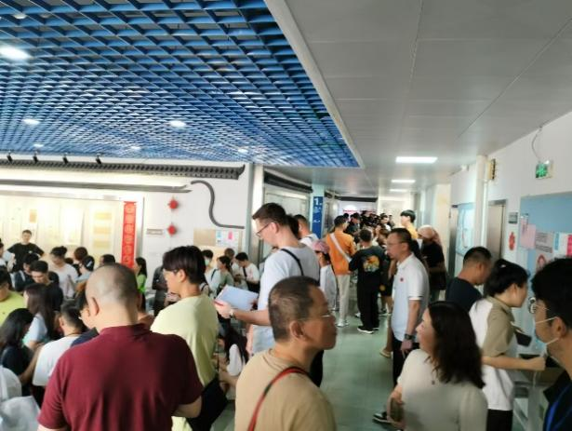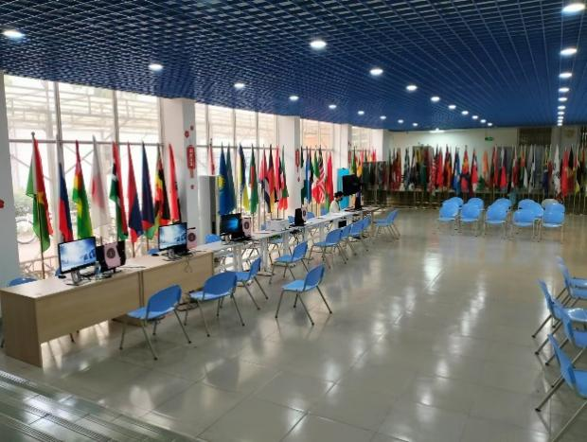

十、报到后须知 Post-Registration Essentials
- 临时住宿登记 Temporary Residence Registration: 所有留学生须在入境后24小时内到派出所办理（校内住宿由宿舍办统一办理）。/ All students must register at local police station within 24 hours of entry (on-campus residents arranged by dorm office).
- 居留许可申请 Residence Permit: X1签证持有者须体检合格后，携材料前往广州市公安局出入境管理局申请。/ X1 holders must apply at Guangzhou Exit & Entry Administration Bureau after passing medical exam.
- 分班测试 Placement Test: 语言进修生须参加汉语水平分班测试。/ Language students must take Chinese placement test.
- 选课 Course Selection: 学历生须在开学第一周内与导师沟通完成选课。 / Degree students must consult supervisors and complete course selection within first week.
- 请假制度 Leave Policy: 开学后因故不能上课，须提前提交书面请假条。 / Submit written leave request in advance if unable to attend class.

十一、重要联系方式汇总 Key Contact Information Summary
事项 Matter | 电话 Phone | 邮箱 Email
报到/签证咨询  Registration/Visa | 0086-20-85215350  / 85210012 | hscic7@scnu.edu.cn
宿舍预订  Dormitory Reservation | 0086-20-85215350  / 85210012 | 20161043@scnu.edu.cn
校园报警（紧急）  Campus Emergency | 0086-20-85211110 | —
校医院（医疗紧急）  University Hospital | 0086-20-85211120 | —
办公时间 Office Hours:
周一至周五 Mon–Fri 8:30–12:00, 14:30–17:30（北京时间 Beijing Time）
暑假 Summer Break: 7月20日-9月3日 July 20th – Sep 3rd

十二、安全提醒 Safety Reminders
- 防范诈骗 Beware of Scams: 请勿向不明账户转账。学校不会通过电话/短信索要银行卡密码或验证码。如接到可疑电话，请挂断并联系学校确认。/ Do NOT transfer money to unknown accounts. The university will NEVER ask for your password or verification code via phone/text. Hang up suspicious calls and contact us to verify.
- 证件安全 Passport Security: 请妥善保管护照，建议随身携带复印件，原件存放于安全处。/ Keep your passport safe. Carry a photocopy and store the original securely.
- 交通安全 Travel Safety: 来华途中注意人身及财物安全，妥善保管护照、现金及贵重物品。/ Take care of personal safety and belongings during travel. Keep passport, cash, and valuables secure.
- 法律遵守 Legal Compliance: 在中国期间须遵守中国法律法规和校纪校规，不得从事任何与学习无关的工作或活动。/ While in China, comply with all Chinese laws, regulations, and university rules. Do NOT engage in any work or activities unrelated to your studies.

期待与大家相见！祝大家旅途平安，报到顺利！
Looking forward to meeting you all! Wish you a safe journey and a smooth registration!
华南师范大学
South China Normal University
2026年7月3日 July 3, 2026

