# **基于教材内容的读后续写教学设计**

林慧静 广州市第六十五中学 英语

一、案例简介

本节课主题语境是人与社会， 人与自我。 本课是基于人教版高中英语Module7 Unit2 Satisfaction guaranteed 课文的读后续写指导课。本单元的课文是一篇科幻小说， 讲述某公司试验机器人托尼的故事。 机器人在方方面面帮助女主人， 最后让女主人对他产生了感情上的依赖。 本节课是在完成课文的阅读理解以及深度思考之后开展的续写指导课， 学生对于文本内在的信息比较熟悉。在前一节课， 教师已经引导学生进行“Further thinking”: Why did Claire fall in love with Tony? How would you rebuild Tony if you were the creator of him? 学生对于这两个问题，有了自己的看法，这为后面的续写做了很好的铺垫。 本节课以续写技巧指导作为主要任务， 包括指导学生如何构建故事情节、 如何列续写提纲以及如何有效应用写作微技能之细节描写。

二、教学设计

1. **教学目标**

能力目标（Ability aims）

The students will be able to:

1. acquire the skills of how to create the plots of a story
2. acquire the skills of making an outline of a story

3) strengthen the ability of describing a person's feelings in details

情感目标（Emotional aims）

The students will be able to：

1)discuss and share their views in the cooperation.

2) learn from the Claire's final realization

1. **教学重难点**

1) Enable students to create plots for a story

2) Enable students to make an outline for a story

3) Strengthen student's ability of describing a person's feelings vividly

1. **教学方法**

任务教学法（Task-based method）; 问题教学法（Question-based method）

1. **教学媒体**

慧学君智慧教学云平台（Huixuejun Teaching Platform）; 多媒体电脑（Mufti-media computer)；课件（Powerpoint）; 黑板（Blackboard）

1. **教学设计理念及流程**

（1）运用任务型语言教学模式，培养学生的语言综合运用能力，重点突出写作微技能的训练。

（2）课堂以学生为主体，鼓励学生充分发挥想象力，构思续写情节和预测结尾。

（3）通过限时写作，训练学生的写作思维能力。

（4）利用智慧君课堂互动平台，提高学生的课堂参与度，并在课堂上评讲学生的作文，检验本节课教学目标的达成度。

（5）本节课的教学流程如下：

**复习文本**

**列出提纲**

**小组讨论**

**研读首句**

**微技能指导**

**完成初稿**

**完成初稿**

**评价修改**

**方法指导**

**评价修改**

1. **教学过程**

|  |  |  |  |
| --- | --- | --- | --- |
| 教学环节及时长 | 教学活动  （包括教师与学生） | 设计意图 | 慧学君课堂互动平台使用情况 |
| **Step I**  Revision (1') | Review the main characters of the story and their relationship. | 让学生明确人物关系，以避免在续写时写一些跟人物关系有矛盾的情节和情感。 | 抢答 |
| **Step II**  Pre-writing (17') | Give some guidance on continuation writing | 写前的方法指导 | 屏幕广播 |
| 1.Presenting a continuation writing task  (1’) | 1.Present a continuation writing task about the story of the text  2. Students circle the key words of the two given sentences  3.Guide students to think by asking a question “What can be inferred about the plots development from these sentences?” | 让学生明确基于课文故事的续写任务以及续写要求；  引导学生迅速捕捉续写首句的关键词以及情感基调 | 屏幕广播；抢答 |
| 2.Group discussion(2’) | Students discuss with their teammates about the plots development (Group work) | 激发学生的好奇心和续写欲望;引发学生间的思维碰撞，以共同构思合理的故事情节及结局。 | 计时器 |
| 3.Making an outline (3') | Students write their own outline for their writing（Individual work） | 鼓励学生充分发挥想象力并列出他们自己的续写提纲 | 随测(主观题);  拍照上传;计时器 |
| 4.Presenting a student’s outline (1’) | Other students judge whether this outline is logical and reasonable. | 引导学生判断该提纲的逻辑性和合理性 | 抢答 |
| 1. Presenting a technique of creating plots   (7’) | Students think of some relevant questions according to the key words of the two given sentences and then speak out their answers | 以“Questions & Answers”环环相扣的问题链形式,引导学生构思故事情节，教师再根据学生的回答来列出情节发展的关键词 | 抢答；随机 |
| 6.Presenting a possible outline(1’) | Students learn how to make an logical and reasonable outline | 指导学生如何在理顺情节线和情感线的基础上列出提纲，为续写明确方向 | 屏幕广播 |
| 7.A micro-skill of writing(1’) | Students learn a micro-skill “To show, not to tell” | 指导学生要通过细节描写来使人物形象更加立体，避免直白地概括性地讲述 | 屏幕广播 |
| 8.Revision of some expressions(1’) | Students review some useful expressions about how to describe a person’s sadness | 鼓励学生把这些表达适当地用于写作中，以达到把情感细化的目标 | 屏幕广播 |
| Step III.  While-writing  (15’) | Students continue the story according to the text and the writing task (Individual Work) | 让学生把本节课学到的续写技能用于实际写作中 | 随测(主观题);  拍照上传 |
| Step IV Post-writing  (5’) | 1.Present an assessment form of continuation writing about “What to write” and “How to write”  2.Evaluate a student’s writing and focus on some expressions about description, including some adjectives and verbs. | 教师堂上解读评价表；  教师评讲学生作文，重点关注微技能的运用情况，检验本节课教学目标的达成度 | 屏幕广播；画笔 |
| Step V  Summary (1’) | Make a summary of the 3 tips for continuation writing  1.Creating plots of a story: Questions & Answers  2.Making an outline: plots line & emotion line  3.Describing a person's feeling in details:“To show, not to tell” | 小结本节课的续写方法指导，确认学生掌握三个写作技能 | 屏幕广播 |
| Assignment (1') | Students finish and polish their writing  Under the expressions about describing a person's feelings in their writing.  Students assess their own writing and their teammates’ writing  (Individual work& Group work) | 学生完成写作并润色；  画出细节描写的表达，明确自己掌握了描写“伤心”的微技能；  根据评价表进行自评和互评。  检验本节课教学目标的达成度 | 屏幕广播 |

三、成效与反思

学生对于从读到写的模式还不够熟悉，在阅读能力方面问题不大，大部分学生能较好地理解原文内容，准确抓住原文的关键信息和给续写埋下的伏笔。但在续写方面，学生的主要问题在于➀学生往往在列了续写提纲之后，不懂得如何充实故事情节，推动故事的发展；➁语言运用的能力不足，在细节描写方面比较弱。学生往往是直白地概括性地讲述，而没有具体的细节描写，在情感细化方面比较弱。因此，针对读后续写的考察目标以及学生的不足之处，本节课在教学设计上，重点指导学生如何构建故事情节、如何列续写提纲以及应用写作微技能之细节描写来使人物形象更加立体。

四、作者简介

林慧静，中学一级教师，任教于广州市第六十五中学高中部，有多年毕业班教学经验。教学紧跟高考改革步伐，深入研究新高考的题型。熟练掌握智慧课堂技术来辅助英语写作教学，提高课堂效率。

五、专家点评

林慧静老师整堂课教学目标清晰，教学效果良好；教师紧抓高考新题型，在教学中积极创新，写前给出明确任务，提供框架支持，引导学生关注语言积累，写中的过程通过问题引导学生建立自己的写作大纲，同时引导学生关注段落各自的侧重点，写后引导学生关注自己的写作情况，进一步反思自己的写作，从而进行分析提升。整体而言，教师的整体教学设计巧妙，教学思路清晰，教学的逻辑性很强。

附录

**（部分课件）**

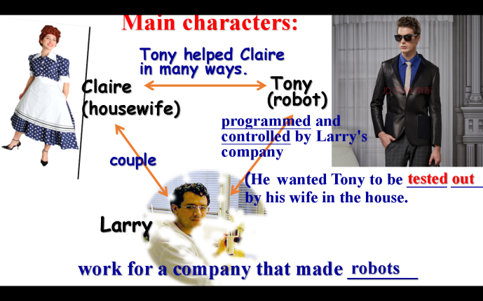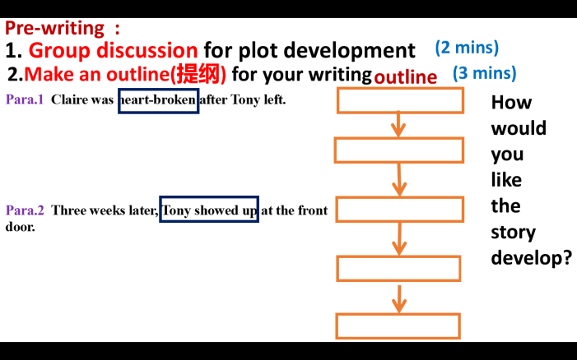

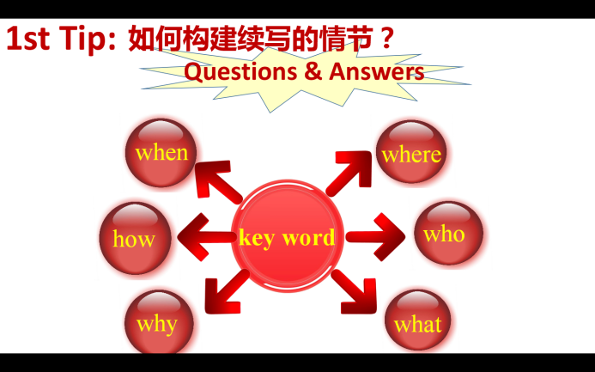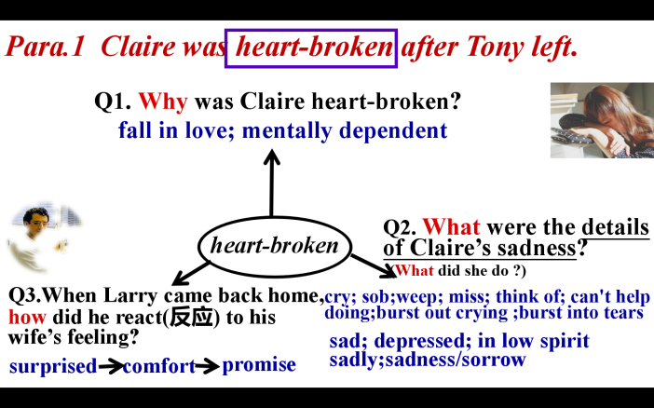

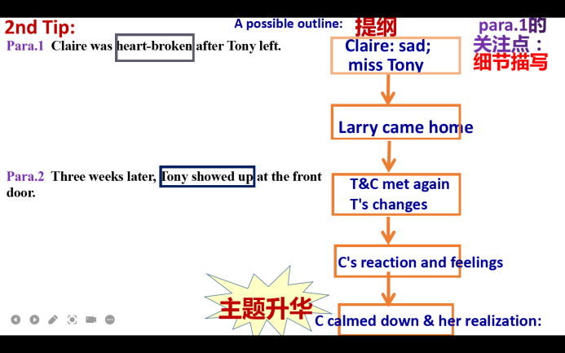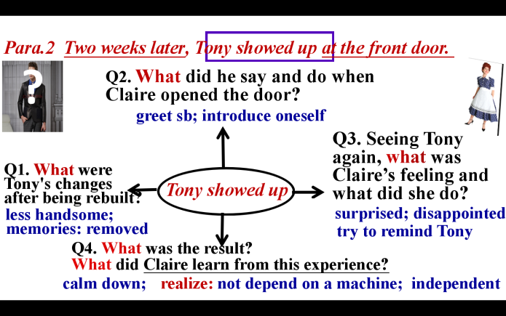

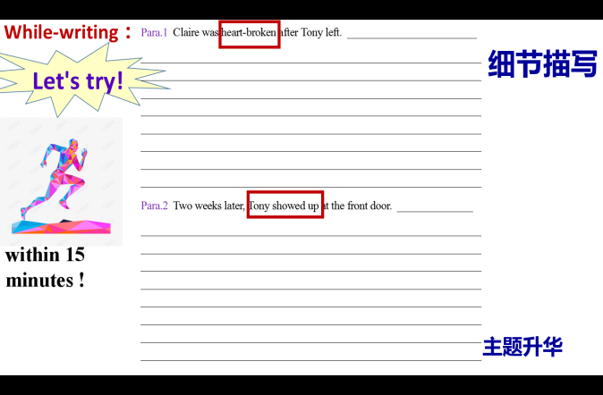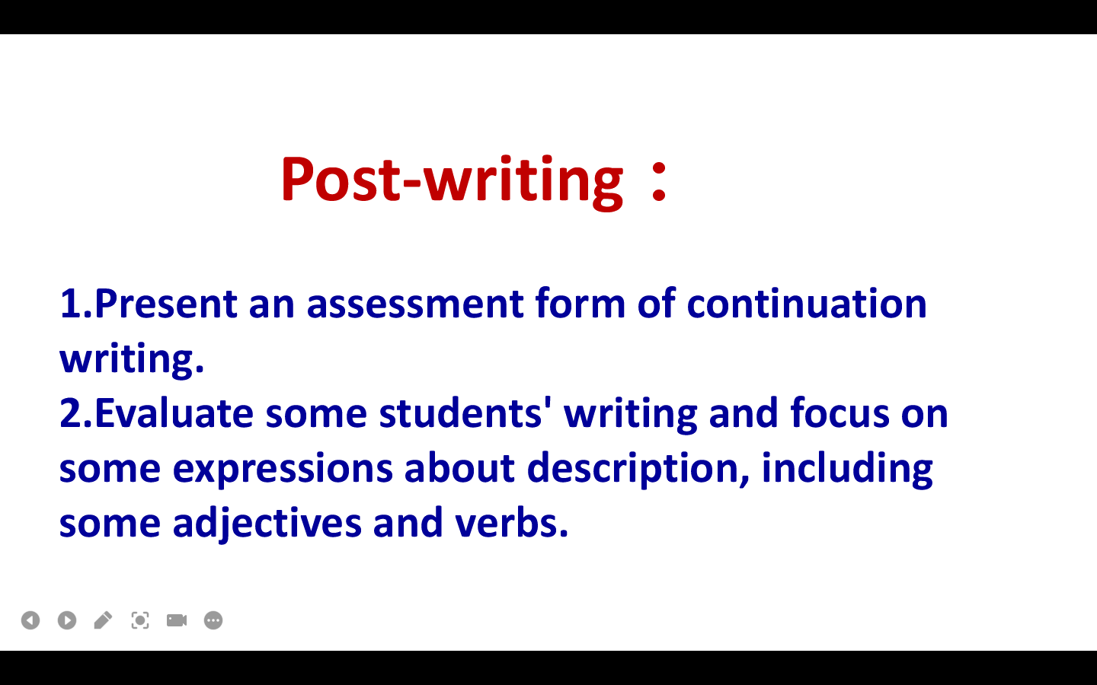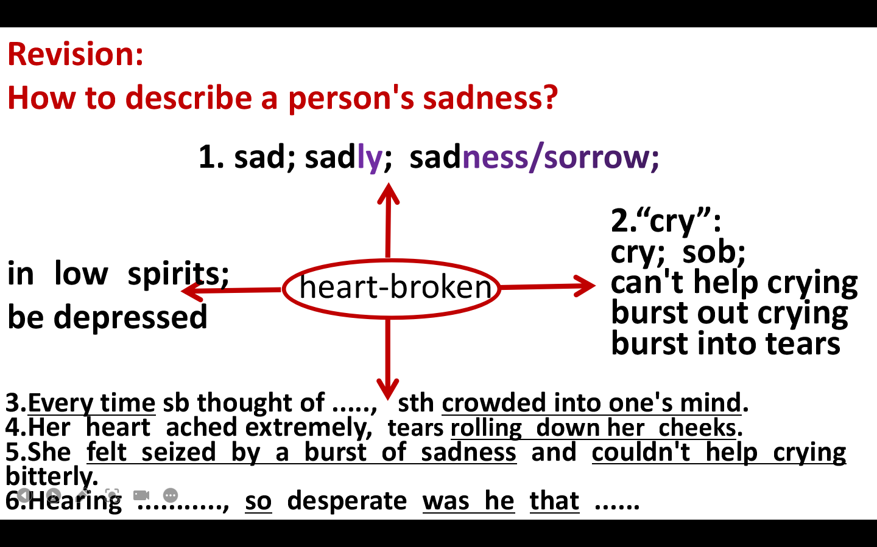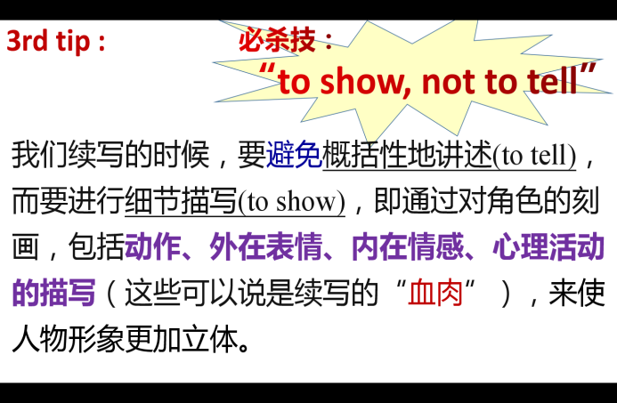

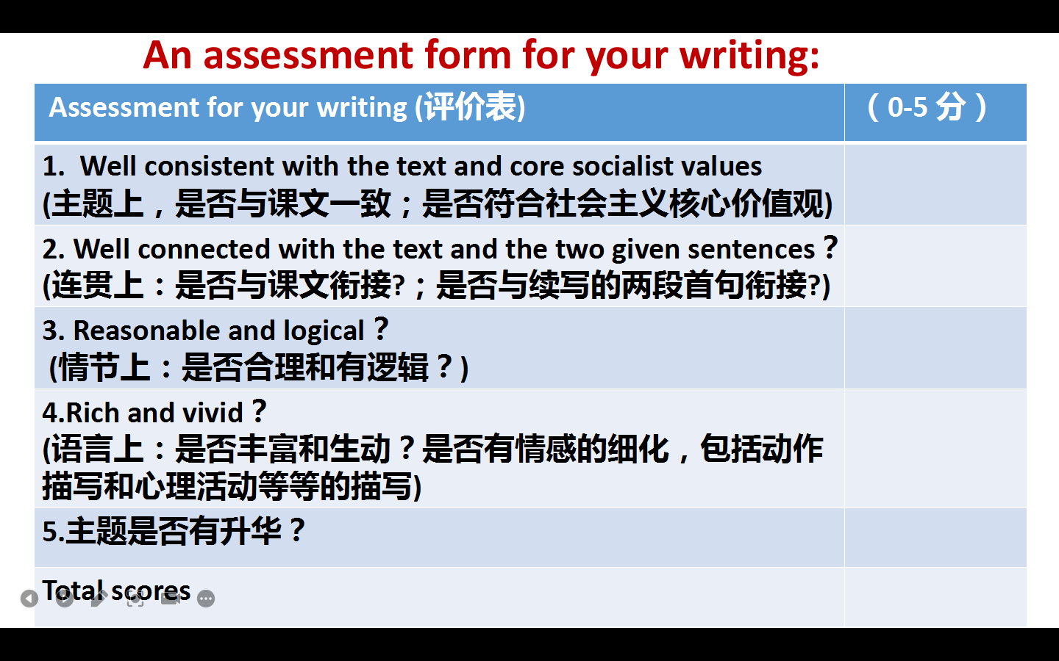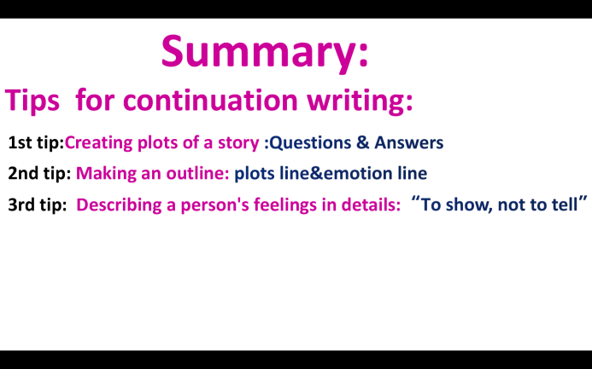

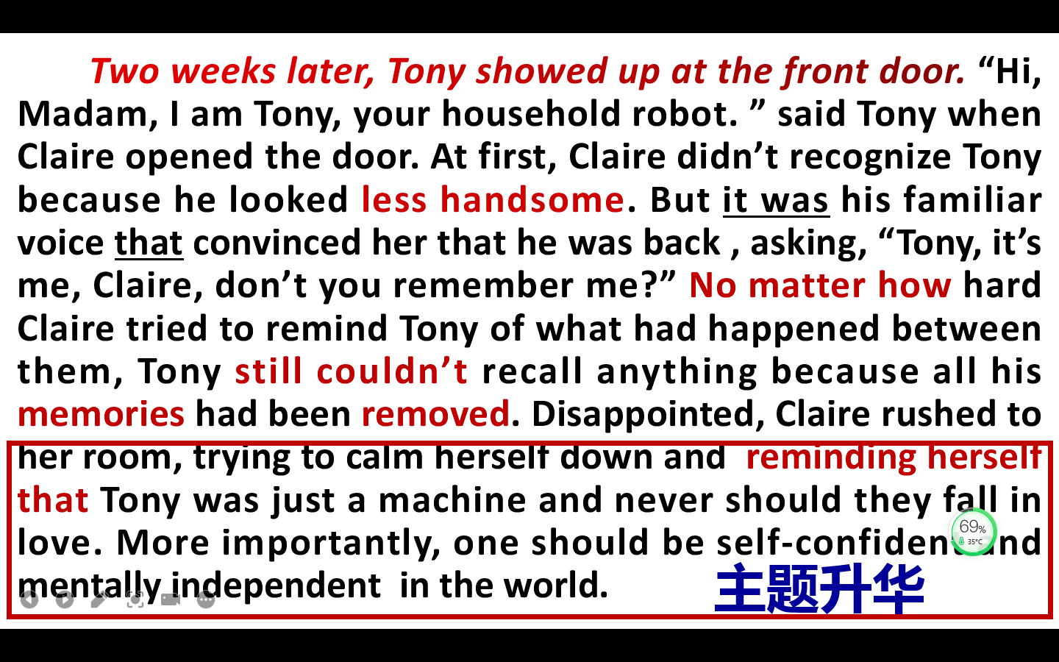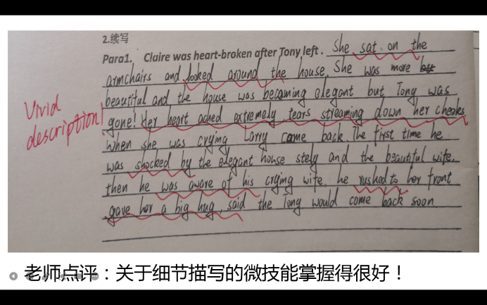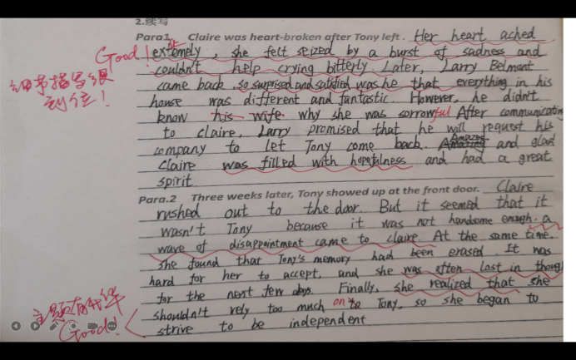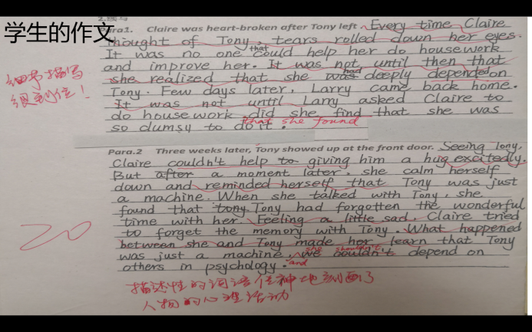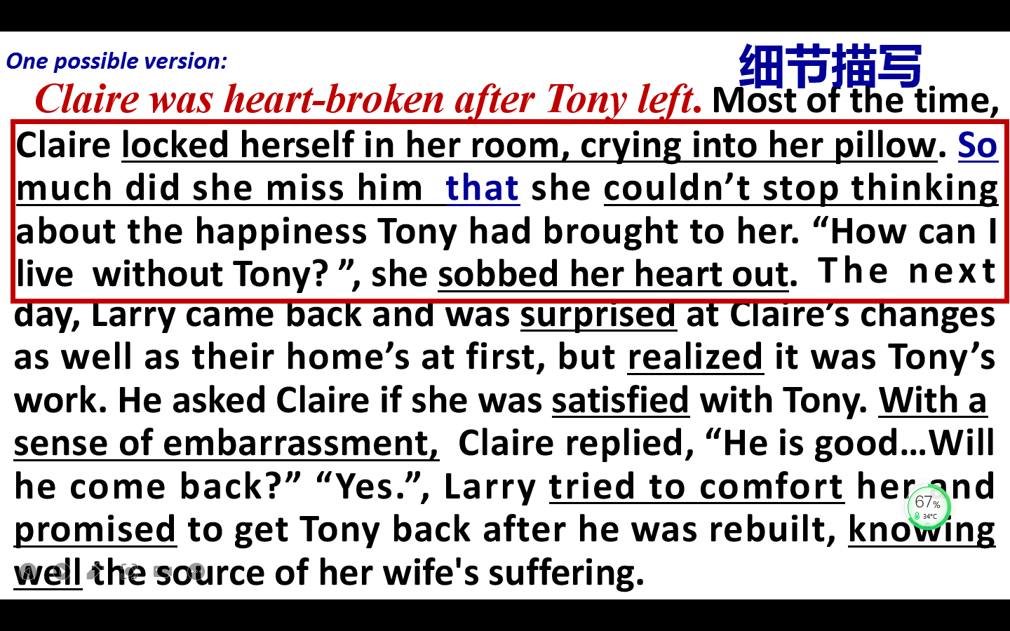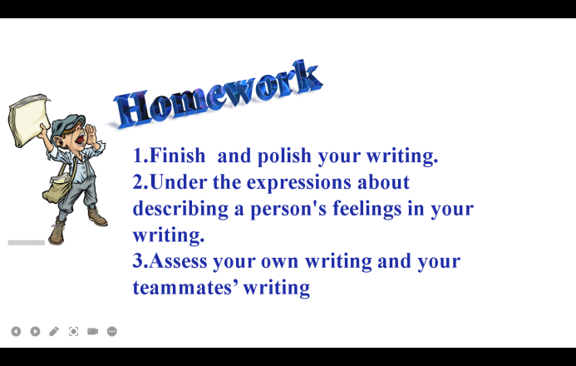

**课前导学案**

Class:_____________ Name:______________ Number:____________

**一．复习并默写以下关于描写“伤心”的表达**

1. “伤心”：(adj. ________________ adv.__________ n.______________)

2.“哭”:

哭__________; 抽泣__________; 忍不住哭____________________；

大哭起来_______________________/_____________________

1. 每次一想到…….. , ........ 就涌上心头

____________________________________________________________________

1. 她心痛极了,泪水顺着脸颊流下来

____________________________________________________________________

1. 她被一股悲伤之感控制，忍不住哭泣。

____________________________________________________________________

1. 一听到……，他如此绝望以致于...

____________________________________________________________________

**深层思考（Further thinking）**

Q1.Why did Claire fall in love with Tony?

______________________________________________________________________________________________________________________

___________________________________________________________

Q2.How would you rebuild Tony if you were the creator of him?

______________________________________________________________________________________________________________________

___________________________________________________________

___________________________________________________________

**课中导学案**

Class:_____________ Name:______________ Number:____________

**学习目标：**

1. 学会合理预测文章中人物和事件的发展趋势，设计符合逻辑的故事情节

2. 掌握写作微技能之细节描写，用丰富的语言描述人物，使人物形象更加立体

3 发挥想象力与创造力，续写故事，从Claire的经历和人生感悟中有所反思

**一.Make an outline（理顺续写的情节）：**

Para1: _________________ _____________ ______________

______________

Para2: _______________ ________________ ________________ ________________

**二．Write down your story.**

***Para1. Claire was heart-broken after Tony left .*** __________________

___________________________________________________________

_____________________________________________________________________________________________________________________________________________________________________________________________________________________________________________________________________________________________________________________________________________________________________________________________________________________________***Para.2 Three weeks later, Tony showed up at the front door.*** _______

___________________________________________________________

___________________________________________________________

___________________________________________________________

___________________________________________________________

___________________________________________________________

___________________________________________________________

___________________________________________________________

___________________________________________________________

**课后自评和互评**

请根据以下评价表，自评和互评作文

|  |  |  |
| --- | --- | --- |
| Assessment for your writing (评价表) | 自评  (0-5分) | 互评  (0-5分) |
| **1**.  Well consistent with the text and core socialist values (主题上，是否与课文一致；是否符合社会主义核心价值观) |  |  |
| 2. Well connected with the text and the two given sentences？ (连贯上：是否与课文衔接?；是否与续写的两段首句衔接?) |  |  |
| 3. Reasonable and logical？ (情节上：是否合理和有逻辑？) |  |  |
| 4.Rich and vivid？ (语言上：是否丰富和生动？是否有情感的细化，包括动作描写和心理活动等等的描写) |  |  |
| 5.主题是否有升华？是否传播正能量？ |  |  |
| Total scores |  |  |